Welcome

What follows is a detailed medical intake form specifically tailored to Classical Chinese medicine. Since Chinese medicine treats the whole person, it is integral that we have detailed information not only pertaining to your current condition but your history. This form also allows me to have a better understanding of who you are. This will help me to begin the treatment with an understanding of your current health and your healthcare goals.

I understand both time and money are limited and valuable. Therefore I have created this form so that time and money are maximized during a treatment. This form saves valuable time for treatment. I appreciate you taking the time to thoroughly and honestly fill this out.

To receive the most benefit from your acupuncture treatments and to avoid side effects, before your visit:

- Bring a list of all medications and supplements you are taking
- Wear no makeup or perfume
- Have a light meal or snack before the visit, as heavy meals can cause nausea and an empty stomach can be the cause of dizziness or lightheadedness after the treatment
- Do not eat or drink anything that changes the color of your tongue
- Do not drink coffee at least 5 hours prior to your appointment and make sure to drink enough water on the day of treatment
- Wear loose clothing

After your visit, it is preferable that you make the rest of your day as easy as possible. Do not drink alcohol or use other intoxicating drugs, or exercise excessively.

Thank you and can’t wait to be your guide on this healing journey,

Kamela Helsing LAc, Mac

Patient Intake
Name _________________________________________________________________________
Last First M.I.

Date of Birth _______________________ Age ________ Gender (circle one): F M

Home number _________________________ Cell number _____________________________ Please circle the preferred phone number to contact you.

Email ___________________________________________________

Emergency Contact _____________________________________________________________
Name
Relationship to Patient __________________________ Phone __________________________

Occupation ___________________________________________ Hrs per week ____________

Are you currently receiving healthcare? yes no

Name and address of physician’s office or clinic that keeps your other medical records.

______________________________________________________________________________
Physician, Clinic and address
_____________________________________________________________________________
City, State, Zip Phone

Consent Regarding Use of Information
_______ At times Kamela Helsing LAc, MAc uses email to correspond with patients as a convenience. However, these emails are not encrypted and could theoretically be read by a malicious outside party with the technical skills to intercept such correspondences. By initialing this section, you consent to allow Kamela Helsing LAc, MAc to correspond with you via email in spite of these potential risks.

_______ It is important to document progress, therefore a photo of each patient is taken during the initial visit and infrequently in subsequent visits. By initialing here, you consent to have your photo taken.

Context of Care

What are your most important health concerns, in order of importance?

- ___________________________________ 3. ______________________________________

- ___________________________________ 4. ______________________________________

Do you have any known contagious diseases at this time? yes no

If yes, what? _____________________________________

What three specific expectations do you have from this visit?

1.

2.

3.

What long-term expectations do you have in working with me?

What expectations do you have of me personally as your healthcare provider?

Describe your current state of health.

What is your level of commitment to address any underlying causes of your symptoms that relate to your lifestyle? Rate from 0 – 10, where 10 is 100% committed.

0 1 2 3 4 5 6 7 8 9 10

What behaviors or lifestyle habits do you engage in regularly that support your health and well-being?

What behaviors or lifestyle habits do you believe are self-destructive or hinder your ability to heal or be healthy?

What potential obstacles do your foresee getting in the way of you addressing the lifestyle factors that are undermining your health and adhering to the treatment guidelines I will give you?

What activities are you passionate about?

Balance
Wellness is a balance of many factors in one’s life. Using the circle below, shade your level of satisfaction in each area as it relates to you.

Each circle represents 20%. Start from the center and shade outwards. For example, if you are 60% satisfied with your work, shade in the inner three circles in the work area.

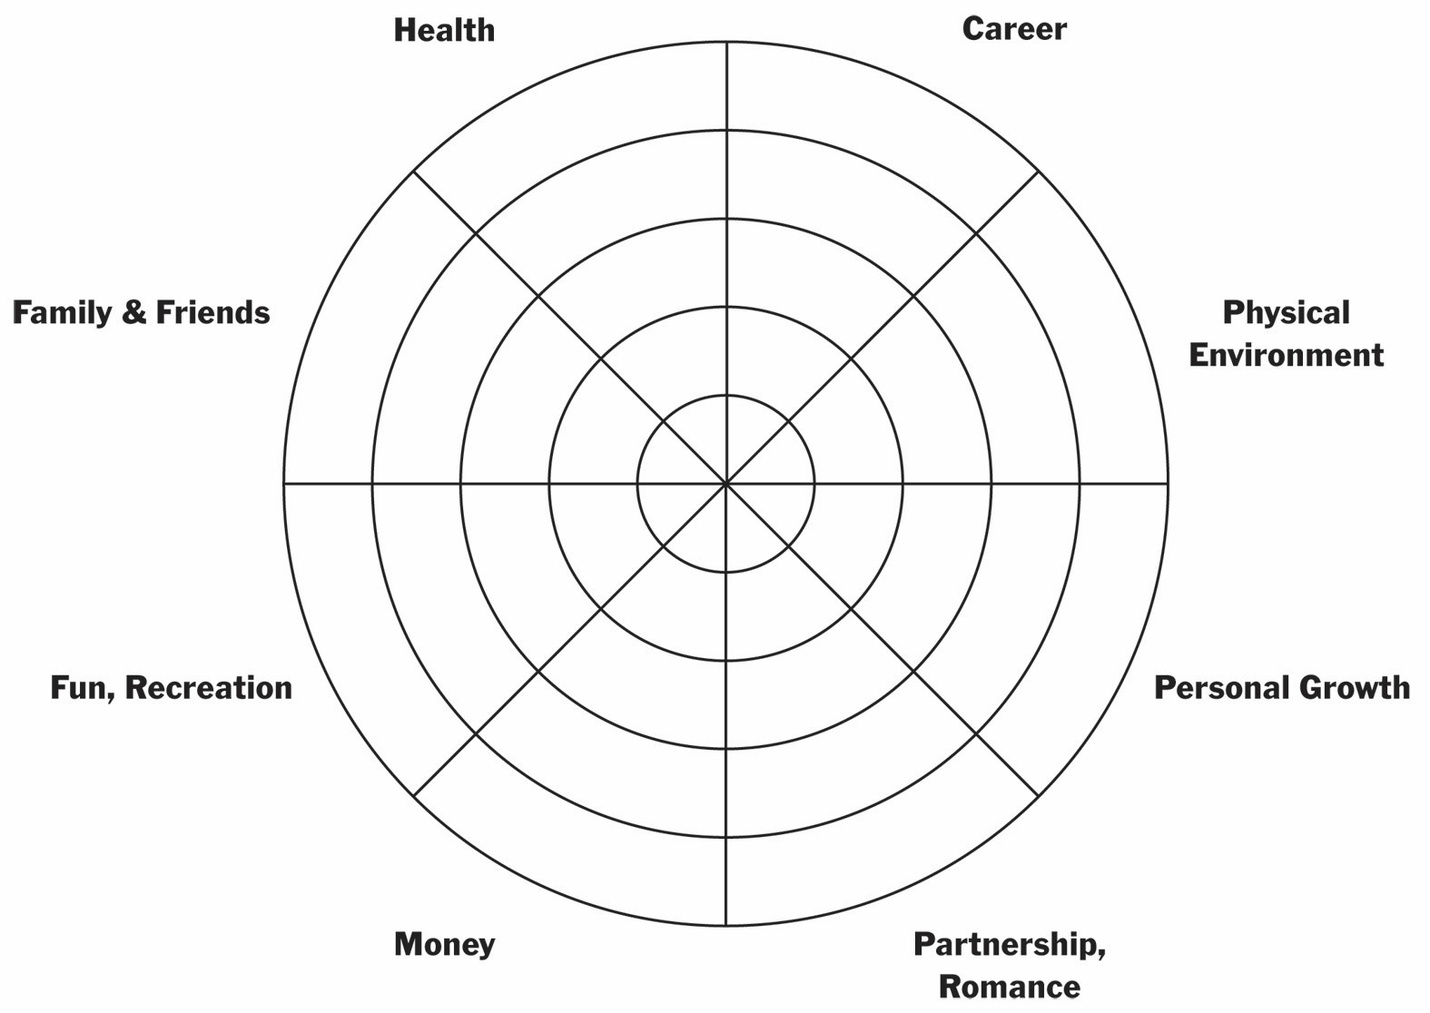

General

Height __________ Current Weight _________ Weight 1 year ago? ________
Preferred Weight ___________
History of trauma? yes no History of abuse? yes no
Hrs of sleep per night _______ Bedtime _______ Do you wake refreshed? yes no
What type of exercise do you do? _______________________________ How often? ________

Current Medications
Do you use any of the following?
⃣⃣⃣⃣⃣⃣ Antacids | ⃣⃣⃣⃣⃣⃣ Tylenol or Advil | ⃣⃣⃣⃣⃣⃣ Oral contraceptives
⃣⃣⃣⃣⃣⃣ Antibiotics | ⃣⃣⃣⃣⃣⃣ Anti-inflammatory medications | ⃣⃣⃣⃣⃣⃣ Laxatives
⃣⃣⃣⃣⃣⃣ Antidepressants | ⃣⃣⃣⃣⃣⃣ Other psychiatric medications | ⃣⃣⃣⃣⃣⃣ Glucose or Insulin
⃣⃣⃣⃣⃣⃣ Aspirin | ⃣⃣⃣⃣⃣⃣ Cholesterol lowering medications | ⃣⃣⃣⃣⃣⃣ Daily vitamins
⃣⃣⃣⃣⃣⃣ Anti-fungals | ⃣⃣⃣⃣⃣⃣ Radiation or Chemotherapy | ⃣⃣⃣⃣⃣⃣ Thyroid medications
⃣⃣⃣⃣⃣⃣ Sleeping Pills | ⃣⃣⃣⃣⃣⃣ Blood pressure medications | ⃣⃣⃣⃣⃣⃣ Recreational or Illegal Drugs

Please list all prescription medications, over-the-counter medications, vitamins, herbs and nutritional supplements you use and how frequently. Include dosages if you can.

Substance Dose + Frequency Date began Reason
1.
2.
3.
4.
5.

Diet, Lifestyle, Habits
Please describe your typical daily meals.

Breakfast ___________________________________________________________________

Lunch ______________________________________________________________________

Dinner ______________________________________________________________________

Snacks _____________________________________________________________________

Please describe what type of sensitivities or allergic reactions you notice to any of the following:

Food _______________________________________________________________________

Medications _________________________________________________________________

Chemicals __________________________________________________________________

Animals ____________________________________________________________________

Do you use or identify with any of the following?
⃣⃣⃣⃣⃣⃣ Fast food outlets | ⃣⃣⃣⃣⃣⃣ Tobacco | ⃣⃣⃣⃣⃣⃣ Craving salty starches
⃣⃣⃣⃣⃣⃣ Coffee | ⃣⃣⃣⃣⃣⃣ Alcohol | ⃣⃣⃣⃣⃣⃣ Craving for sweets
⃣⃣⃣⃣⃣⃣ Energy drinks | ⃣⃣⃣⃣⃣⃣ History of dieting | ⃣⃣⃣⃣⃣⃣ History of eating disorders
⃣⃣⃣⃣⃣⃣ Sodas | ⃣⃣⃣⃣⃣⃣ Eat at night or near bedtime | ⃣⃣⃣⃣⃣⃣ Reward yourself with food

Patient Medical History
Describe your childhood health. ___________________________________________________

Operations and Hospitalizations
Date Diagnosis Operation/Surgery Physician
1.
2.
3.
4.
5.

Recent Tests (within the past year)
Test Date Results
Physical Exam
Blood Pressure
Cholesterol
Blood Work – which test?

X-Rays
CT Scan
EKG/EEG
Mammography
Bone Density (DEXA)
Pap Smear
Prostate
HIV/STD
Other:

Check any you have or have had in the past:
⃣⃣⃣⃣⃣⃣ Heart Disease | ⃣⃣⃣⃣⃣⃣ Hypertension | ⃣⃣⃣⃣⃣⃣ Mitral Valve Prolapse | ⃣⃣⃣⃣⃣⃣ Vein Condition
⃣⃣⃣⃣⃣⃣ Heart Murmur | ⃣⃣⃣⃣⃣⃣ Stroke | ⃣⃣⃣⃣⃣⃣ Blood Clots | ⃣⃣⃣⃣⃣⃣ Bleeding Tendency
⃣⃣⃣⃣⃣⃣ Bronchitis | ⃣⃣⃣⃣⃣⃣ Pneumonia | ⃣⃣⃣⃣⃣⃣ Tuberculosis | ⃣⃣⃣⃣⃣⃣ Emphysema
⃣⃣⃣⃣⃣⃣ Asthma | ⃣⃣⃣⃣⃣⃣ High Cholesterol | ⃣⃣⃣⃣⃣⃣ Ulcers | ⃣⃣⃣⃣⃣⃣ Colitis/Enteritis
⃣⃣⃣⃣⃣⃣ Diabetes | ⃣⃣⃣⃣⃣⃣ Polio | ⃣⃣⃣⃣⃣⃣ Recent Immunization | ⃣⃣⃣⃣⃣⃣ Thyroid Disorder
⃣⃣⃣⃣⃣⃣ HIV | ⃣⃣⃣⃣⃣⃣ Gonorrhea | ⃣⃣⃣⃣⃣⃣ Syphilis | ⃣⃣⃣⃣⃣⃣ Rheumatic Fever
⃣⃣⃣⃣⃣⃣ Mumps | ⃣⃣⃣⃣⃣⃣ Measles | ⃣⃣⃣⃣⃣⃣ Chicken Pox | ⃣⃣⃣⃣⃣⃣ Mononucleosis
⃣⃣⃣⃣⃣⃣ Meningitis | ⃣⃣⃣⃣⃣⃣ Jaundice | ⃣⃣⃣⃣⃣⃣ Gallbladder problems | ⃣⃣⃣⃣⃣⃣ Hepatitis ______
⃣⃣⃣⃣⃣⃣ Epilepsy | ⃣⃣⃣⃣⃣⃣ High Fever | ⃣⃣⃣⃣⃣⃣ Glaucoma | ⃣⃣⃣⃣⃣⃣ Multiple Sclerosis
⃣⃣⃣⃣⃣⃣ Paralysis | ⃣⃣⃣⃣⃣⃣ Cancer | ⃣⃣⃣⃣⃣⃣ Migraines | ⃣⃣⃣⃣⃣⃣ Nervous/Psychiatric
Disorder

Other illnesses/diseases _________________________________________________________
Immunizations _________________________________________________________________

Family History

Current age or
age at death
(circle age if
deceased) Health Problems
Mother
Father
Sister(s)
Brother(s)
Daughter(s)
Son(s)

Check below any conditions you have a family history of.
⃣⃣⃣⃣⃣⃣ Cancer | ⃣⃣⃣⃣⃣⃣ Diabetes | ⃣⃣⃣⃣⃣⃣ Heart Disease | ⃣⃣⃣⃣⃣⃣ Hypertension
⃣⃣⃣⃣⃣⃣ Kidney disease | ⃣⃣⃣⃣⃣⃣ Epilepsy | ⃣⃣⃣⃣⃣⃣ Arthritis | ⃣⃣⃣⃣⃣⃣ Glaucoma
⃣⃣⃣⃣⃣⃣ Tuberculosis | ⃣⃣⃣⃣⃣⃣ Stroke | ⃣⃣⃣⃣⃣⃣ Anemia | ⃣⃣⃣⃣⃣⃣ Mental Illness
⃣⃣⃣⃣⃣⃣ Alcoholism | ⃣⃣⃣⃣⃣⃣ Obesity | ⃣⃣⃣⃣⃣⃣ Stroke | ⃣⃣⃣⃣⃣⃣ Nervous Illness
⃣⃣⃣⃣⃣⃣ High Cholesterol | ⃣⃣⃣⃣⃣⃣ Endometriosis | ⃣⃣⃣⃣⃣⃣ Uterine Fibroids | ⃣⃣⃣⃣⃣⃣ Venous Thrombosis (blood  clotting)

Other relevant history ___________________________________________________________

______________________________________________________________________________
Pain and Scars
If you are currently experiencing pain or if you have scars anywhere on your body, please mark the figures below with the letters that best describe the sensation or pain you are feeling and draw in the areas of scarring. Please mark areas where pain radiates or spreads with an arrow to indicate the direction of radiating pain. (Include all affected areas)

A – Aching | B – Burning | R – Radiating | D – Dull
F – Fixed | C – Cramping | S – Sharp/Stabbing | N – Numbness
P – Pins & Needles | **Draw in scars
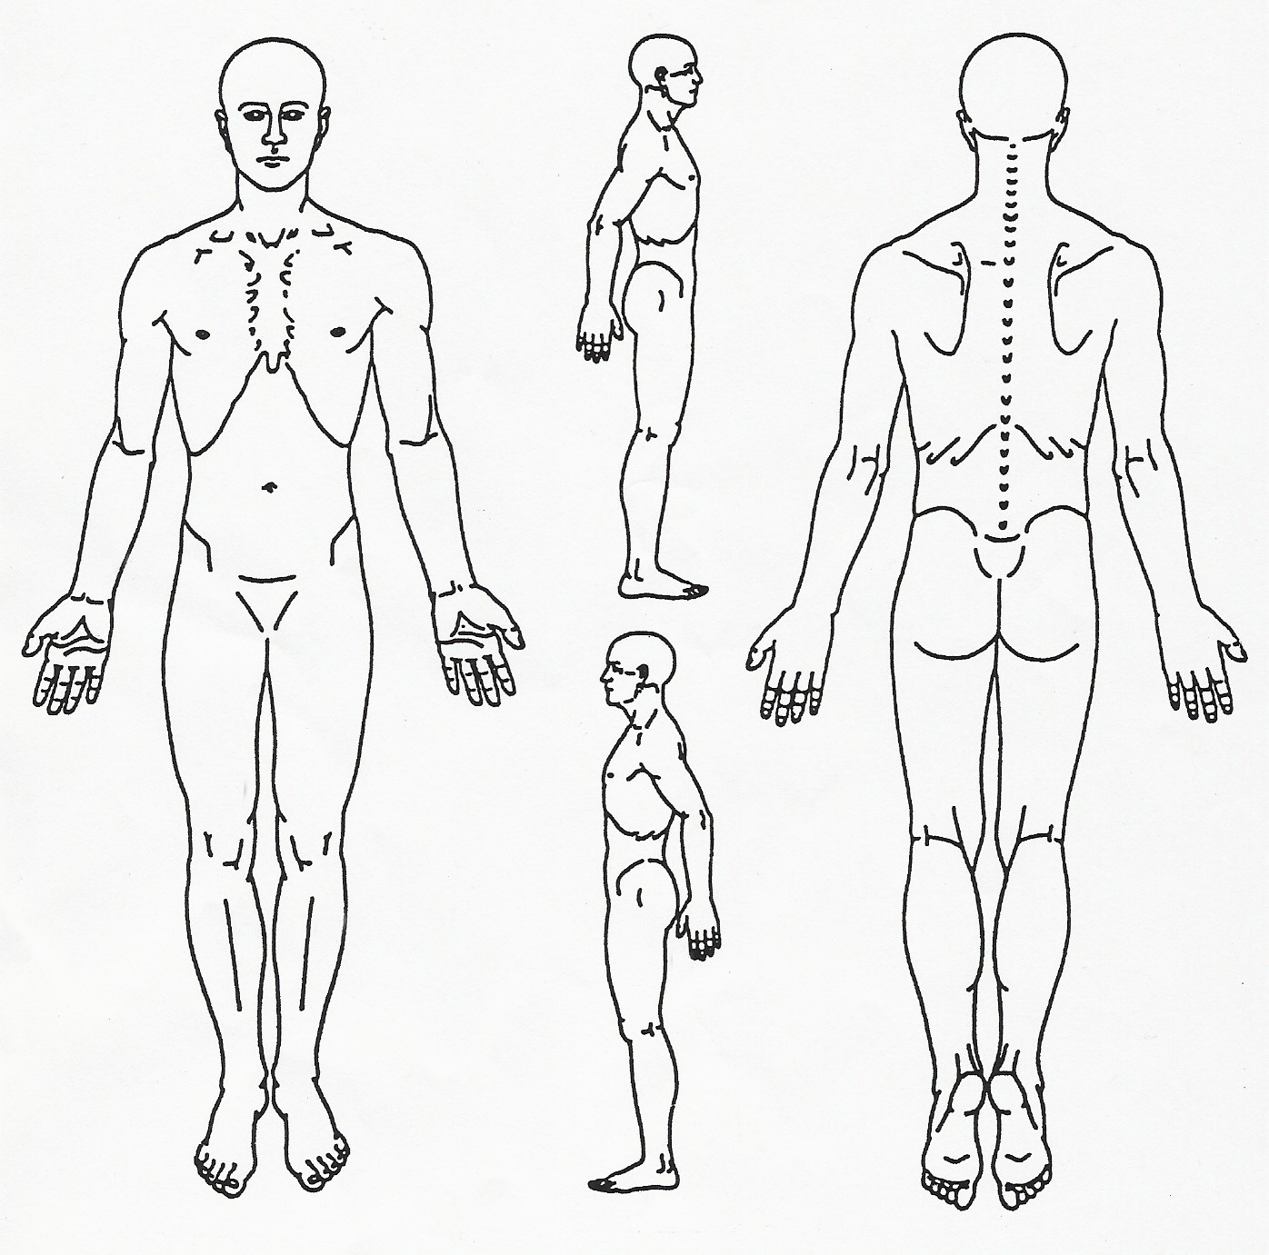
⃣⃣⃣⃣⃣⃣
⃣⃣⃣⃣⃣⃣
⃣⃣⃣⃣⃣⃣
⃣⃣⃣⃣⃣⃣
⃣⃣⃣⃣⃣⃣
⃣⃣⃣⃣⃣⃣
⃣⃣⃣⃣⃣⃣
⃣⃣⃣⃣⃣⃣
⃣⃣⃣⃣⃣⃣
⃣⃣⃣⃣⃣⃣
⃣⃣⃣⃣⃣⃣
⃣⃣⃣⃣⃣⃣
⃣⃣⃣⃣⃣⃣
⃣⃣⃣⃣⃣⃣
⃣⃣⃣⃣⃣⃣
⃣⃣⃣⃣⃣⃣
⃣⃣⃣⃣⃣⃣
⃣⃣⃣⃣⃣⃣
⃣⃣⃣⃣⃣⃣
⃣⃣⃣⃣⃣⃣
⃣⃣⃣⃣⃣⃣
⃣⃣⃣⃣⃣⃣
⃣⃣⃣⃣⃣⃣
⃣⃣⃣⃣⃣⃣
⃣⃣⃣⃣⃣⃣
⃣⃣⃣⃣⃣⃣
⃣⃣⃣⃣⃣⃣
Please indicate how you would rate your overall state pain: (Low) 0 1 2 3 4 5 6 7 8 9 10 (High)

What makes the pain better? What makes the pain worse?
⃣⃣⃣⃣⃣⃣ Soft Pressure ⃣⃣⃣⃣⃣⃣ Soft Pressure
⃣⃣⃣⃣⃣⃣ Hard Pressure ⃣⃣⃣⃣⃣⃣ Hard Pressure
⃣⃣⃣⃣⃣⃣ Warmth/Heat ⃣⃣⃣⃣⃣⃣ Warmth/Heat
⃣⃣⃣⃣⃣⃣ Cold ⃣⃣⃣⃣⃣⃣ Cold
⃣⃣⃣⃣⃣⃣ Exercise ⃣⃣⃣⃣⃣⃣ Exercise
⃣⃣⃣⃣⃣⃣ Rest ⃣⃣⃣⃣⃣⃣ Rest
⃣⃣⃣⃣⃣⃣ Other ⃣⃣⃣⃣⃣⃣ Other

Systems and Symptoms

Kidney Function  (Overall Temperature) | Lung, Kidney Function (Overall Energy) | Lung Function
⃣⃣⃣⃣⃣⃣ Cold Hands | ⃣⃣⃣⃣⃣⃣ Shortness of breath | ⃣⃣⃣⃣⃣⃣ Nasal discharge (color ____________)
⃣⃣⃣⃣⃣⃣ Cold Fingers | ⃣⃣⃣⃣⃣⃣ Hard to keep eyes open (day) | ⃣⃣⃣⃣⃣⃣ Cough
⃣⃣⃣⃣⃣⃣ Cold Toes | ⃣⃣⃣⃣⃣⃣ General weakness | ⃣⃣⃣⃣⃣⃣ Nosebleeds
⃣⃣⃣⃣⃣⃣ Cold Feet | ⃣⃣⃣⃣⃣⃣ Easily catch colds | ⃣⃣⃣⃣⃣⃣ Sinus congestion
⃣⃣⃣⃣⃣⃣ Sweaty Hands | ⃣⃣⃣⃣⃣⃣ Low energy | ⃣⃣⃣⃣⃣⃣ Dry mouth
⃣⃣⃣⃣⃣⃣ Sweaty Feet | ⃣⃣⃣⃣⃣⃣ Feel worse after exercise | ⃣⃣⃣⃣⃣⃣ Dry throat
⃣⃣⃣⃣⃣⃣ Hot body temp sensation | ⃣⃣⃣⃣⃣⃣ Chronic (daily) fatigue, malaise | ⃣⃣⃣⃣⃣⃣ Dry nose
⃣⃣⃣⃣⃣⃣ Cold body temp sensation |  | ⃣⃣⃣⃣⃣⃣ Dry skin
⃣⃣⃣⃣⃣⃣ Afternoon flushes | Heart Function | ⃣⃣⃣⃣⃣⃣ Scaly skin
⃣⃣⃣⃣⃣⃣ Night sweats | ⃣⃣⃣⃣⃣⃣ Anxiety | ⃣⃣⃣⃣⃣⃣ Allergies
⃣⃣⃣⃣⃣⃣ Heat in hands, feet and chest | ⃣⃣⃣⃣⃣⃣ Sores on tip of tongue | ⃣⃣⃣⃣⃣⃣ Sneezing
⃣⃣⃣⃣⃣⃣ Hot flashes any time of day | ⃣⃣⃣⃣⃣⃣ Restlessness | ⃣⃣⃣⃣⃣⃣ Alternating chills/fever
⃣⃣⃣⃣⃣⃣ Thirsty | ⃣⃣⃣⃣⃣⃣ Mental confusion | ⃣⃣⃣⃣⃣⃣ Headache
⃣⃣⃣⃣⃣⃣ Perspire easily | ⃣⃣⃣⃣⃣⃣ Chest pain traveling to shldr-arm | ⃣⃣⃣⃣⃣⃣ Overall achy feeling in body
⃣⃣⃣⃣⃣⃣ Lack of perspiration | ⃣⃣⃣⃣⃣⃣ Palpitations or heart racing | ⃣⃣⃣⃣⃣⃣ Stiff neck
⃣⃣⃣⃣⃣⃣ Take water to bed with you | ⃣⃣⃣⃣⃣⃣ Frequent dreams | ⃣⃣⃣⃣⃣⃣ Stiff shoulders
 | ⃣⃣⃣⃣⃣⃣ Wake unrefreshed | ⃣⃣⃣⃣⃣⃣ Sore throat
Liver, Heart, Spleen Function | ⃣⃣⃣⃣⃣⃣ Cold body temp sensation | ⃣⃣⃣⃣⃣⃣ Difficulty breathing
⃣⃣⃣⃣⃣⃣ Dizziness | ⃣⃣⃣⃣⃣⃣ Speech problems | ⃣⃣⃣⃣⃣⃣ Sadness
⃣⃣⃣⃣⃣⃣ See floating black spots | ⃣⃣⃣⃣⃣⃣ Coffee? Cups/day ________ | ⃣⃣⃣⃣⃣⃣ Melancholy
 |  | ⃣⃣⃣⃣⃣⃣ Smoke cigarettes (#/day _____)
Spleen Function | Stomach Function | Spleen, Stomach, SI, LI Function
⃣⃣⃣⃣⃣⃣ Low appetite | ⃣⃣⃣⃣⃣⃣ Burning sensation after eating | ⃣⃣⃣⃣⃣⃣ Loose stools
⃣⃣⃣⃣⃣⃣ Abrupt weight gain | ⃣⃣⃣⃣⃣⃣ Large appetite | ⃣⃣⃣⃣⃣⃣ Diarrhea
⃣⃣⃣⃣⃣⃣ Abrupt weight loss | ⃣⃣⃣⃣⃣⃣ Bad breath | ⃣⃣⃣⃣⃣⃣ Constipation
⃣⃣⃣⃣⃣⃣ Abdominal bloating | ⃣⃣⃣⃣⃣⃣ Canker sores (mouth) | ⃣⃣⃣⃣⃣⃣ Incomplete stools
⃣⃣⃣⃣⃣⃣ Abdominal gas | ⃣⃣⃣⃣⃣⃣ Bleeding, swollen, painful gums | ⃣⃣⃣⃣⃣⃣ Blood in stools
⃣⃣⃣⃣⃣⃣ Gurgling noise in stomach | ⃣⃣⃣⃣⃣⃣ Heartburn | ⃣⃣⃣⃣⃣⃣ Mucous in stools
⃣⃣⃣⃣⃣⃣ Fatigue after eating | ⃣⃣⃣⃣⃣⃣ Acid regurgitation | ⃣⃣⃣⃣⃣⃣ Undigested food in stools
⃣⃣⃣⃣⃣⃣ Prolapsed organs | ⃣⃣⃣⃣⃣⃣ Ulcer
Which? _________________ | ⃣⃣⃣⃣⃣⃣ Belching
⃣⃣⃣⃣⃣⃣ Bruise easily | ⃣⃣⃣⃣⃣⃣ Hiccoughs
⃣⃣⃣⃣⃣⃣ Over-thinking | ⃣⃣⃣⃣⃣⃣ Stomach pain
⃣⃣⃣⃣⃣⃣ Worry | ⃣⃣⃣⃣⃣⃣ Vomiting
⃣⃣⃣⃣⃣⃣ Sedentary work
⃣⃣⃣⃣⃣⃣ Physical labor
⃣⃣⃣⃣⃣⃣ Muscle weakness/fatigue

Dampness Trapped in Body | Liver, Gall Bladder Function | Urination (Bladder Function)
⃣⃣⃣⃣⃣⃣ Mental fogginess | ⃣⃣⃣⃣⃣⃣ Rib-side pain | ⃣⃣⃣⃣⃣⃣ Pale ⃣⃣⃣⃣⃣⃣ Dk yellow ⃣⃣⃣⃣⃣⃣ Clear  ⃣⃣⃣⃣⃣⃣ Reddish
⃣⃣⃣⃣⃣⃣ Bodily sensation of heaviness | ⃣⃣⃣⃣⃣⃣ Alternating diarrhea-constipation | ⃣⃣⃣⃣⃣⃣ Cloudy ⃣⃣⃣⃣⃣⃣ Strong odor
⃣⃣⃣⃣⃣⃣ Mental heaviness | ⃣⃣⃣⃣⃣⃣ Chest pain | ⃣⃣⃣⃣⃣⃣ Profuse ⃣⃣⃣⃣⃣⃣ Scanty/reduced amt
⃣⃣⃣⃣⃣⃣ Mental sluggishness | ⃣⃣⃣⃣⃣⃣ Tight sensation in the chest | ⃣⃣⃣⃣⃣⃣ Burning ⃣⃣⃣⃣⃣⃣ Painful
⃣⃣⃣⃣⃣⃣ Mental fogginess | ⃣⃣⃣⃣⃣⃣ Bitter taste in the mouth | ⃣⃣⃣⃣⃣⃣ Discharge ⃣⃣⃣⃣⃣⃣ Urgent
⃣⃣⃣⃣⃣⃣ Swollen hands | ⃣⃣⃣⃣⃣⃣ Anger easily | ⃣⃣⃣⃣⃣⃣ Difficult ⃣⃣⃣⃣⃣⃣ Incomplete
⃣⃣⃣⃣⃣⃣ Swollen feet or ankles | ⃣⃣⃣⃣⃣⃣ Depression | ⃣⃣⃣⃣⃣⃣ Frequent # times/day ________
⃣⃣⃣⃣⃣⃣ Swollen joints | ⃣⃣⃣⃣⃣⃣ Frustration
⃣⃣⃣⃣⃣⃣ Chest congestion | ⃣⃣⃣⃣⃣⃣ Irritability | Kidney, Bladder Function
⃣⃣⃣⃣⃣⃣ Nausea | ⃣⃣⃣⃣⃣⃣ Skin rashes | ⃣⃣⃣⃣⃣⃣ Frequent cavities, teeth problems
⃣⃣⃣⃣⃣⃣ Snoring | ⃣⃣⃣⃣⃣⃣ Pain increases with stress | ⃣⃣⃣⃣⃣⃣ Easily broken bones
 | ⃣⃣⃣⃣⃣⃣ Tingling sensation | ⃣⃣⃣⃣⃣⃣ Sore knees
Liver Function (Eyes) | ⃣⃣⃣⃣⃣⃣ Numbness | ⃣⃣⃣⃣⃣⃣ Weak knees
⃣⃣⃣⃣⃣⃣ Itchy | ⃣⃣⃣⃣⃣⃣ Muscle twitch, cramp, spasm | ⃣⃣⃣⃣⃣⃣ Cold sensation in the knees
⃣⃣⃣⃣⃣⃣ Red | ⃣⃣⃣⃣⃣⃣ Seizures | ⃣⃣⃣⃣⃣⃣ Low back pain
⃣⃣⃣⃣⃣⃣ Bloodshot | ⃣⃣⃣⃣⃣⃣ Convulsions | ⃣⃣⃣⃣⃣⃣ Memory problems
⃣⃣⃣⃣⃣⃣ Hot | ⃣⃣⃣⃣⃣⃣ Yellow eyes or skin | ⃣⃣⃣⃣⃣⃣ Excessive hair loss
⃣⃣⃣⃣⃣⃣ Dry | ⃣⃣⃣⃣⃣⃣ Migraines, headaches | ⃣⃣⃣⃣⃣⃣ Low-pitched ringing in the ears
⃣⃣⃣⃣⃣⃣ Watery | ⃣⃣⃣⃣⃣⃣ Lump in the throat | ⃣⃣⃣⃣⃣⃣ Puffy or dark circles beneath eyes
⃣⃣⃣⃣⃣⃣ Gritty | ⃣⃣⃣⃣⃣⃣ Neck tension | ⃣⃣⃣⃣⃣⃣ Osteo- or Rheumatoid Arthritis
⃣⃣⃣⃣⃣⃣ Blurry vision | ⃣⃣⃣⃣⃣⃣ Shoulder tension | ⃣⃣⃣⃣⃣⃣ Morning diarrhea
⃣⃣⃣⃣⃣⃣ Decreased night vision | ⃣⃣⃣⃣⃣⃣ Lmtd motion neck/shoulder | ⃣⃣⃣⃣⃣⃣ Kidney stones
⃣⃣⃣⃣⃣⃣ Near-sighted | ⃣⃣⃣⃣⃣⃣ Amt of alcohol/day ___________ | ⃣⃣⃣⃣⃣⃣ Bladder infections
⃣⃣⃣⃣⃣⃣ Far-sighted | ⃣⃣⃣⃣⃣⃣ Recreational drugs ___________ | ⃣⃣⃣⃣⃣⃣ Lack of bladder control
 | ⃣⃣⃣⃣⃣⃣ High-pitched ringing in ears | ⃣⃣⃣⃣⃣⃣ Wake >2x/night to urinate
Libido (Sex Drive) | ⃣⃣⃣⃣⃣⃣ Gall stones (history or current) | ⃣⃣⃣⃣⃣⃣ Easily startled
⃣⃣⃣⃣⃣⃣ Normal | ⃣⃣⃣⃣⃣⃣ STDs | ⃣⃣⃣⃣⃣⃣ Fear
⃣⃣⃣⃣⃣⃣ High | ⃣⃣⃣⃣⃣⃣ Unable to adapt to stress
⃣⃣⃣⃣⃣⃣ Low
 | Women Only | Women Only
Men Only | ⃣⃣⃣⃣⃣⃣ Nausea | ⃣⃣⃣⃣⃣⃣ Dull pain Where______________
⃣⃣⃣⃣⃣⃣ Swollen testes | ⃣⃣⃣⃣⃣⃣ Vomiting | ⃣⃣⃣⃣⃣⃣ Sharp pain Where ____________
⃣⃣⃣⃣⃣⃣ Testicular pain | ⃣⃣⃣⃣⃣⃣ Food cravings | _____ Age of first menstruation
⃣⃣⃣⃣⃣⃣ Penile pain | ⃣⃣⃣⃣⃣⃣ Water retention | _____ Avge # days in flow
⃣⃣⃣⃣⃣⃣ Penile discharge or sores | ⃣⃣⃣⃣⃣⃣ Breast swelling | _____ Avge # days in entire cycle
⃣⃣⃣⃣⃣⃣ Erectile difficulty | ⃣⃣⃣⃣⃣⃣ Breast tenderness | _____ # children
⃣⃣⃣⃣⃣⃣ Impotence | ⃣⃣⃣⃣⃣⃣ Breast lumps | _____ # pregnancies
⃣⃣⃣⃣⃣⃣ Premature ejaculation | ⃣⃣⃣⃣⃣⃣ Headaches | _____ Age of menopause (if applicable)
⃣⃣⃣⃣⃣⃣ Feeling of coldness or numbness | ⃣⃣⃣⃣⃣⃣ Migraines | ⃣⃣⃣⃣⃣⃣ yes ⃣⃣⃣⃣⃣⃣ no Regular menstrual cycle?
in external genitalia | ⃣⃣⃣⃣⃣⃣ Depression | ⃣⃣⃣⃣⃣⃣ yes ⃣⃣⃣⃣⃣⃣ no Are you pregnant?
⃣⃣⃣⃣⃣⃣ Hernia | ⃣⃣⃣⃣⃣⃣ Irritability | ⃣⃣⃣⃣⃣⃣ yes ⃣⃣⃣⃣⃣⃣ no Bleeding between periods?
⃣⃣⃣⃣⃣⃣ Other ______________________ | ⃣⃣⃣⃣⃣⃣ Anxiety | ⃣⃣⃣⃣⃣⃣ yes ⃣⃣⃣⃣⃣⃣ no Vaginal discharge?

Date of last menses_________________________

Women: Please fill in the menstrual chart.
 | Color  (normal, pale, bright red, brown, dark purple, other?) | Amount of flow  (Normal, heavy, light) | Pain/Cramps  (dull, sharp, other) | Vomiting  (check if yes)
Day 1
Day 2
Day 3
Day 4
Day 5
Day 6
Day 7

Are there any other health concerns that you have which have not been covered in this questionnaire?

________________________________________________________________________
________________________________________________________________________
________________________________________________________________________
_______________________________________________________________________
Signature Date

Thank you for taking the time to fill out this questionnaire.

HIPAA Notice of Privacy Practices

Please review this notice carefully. It describes how medical information about you may be used and disclosed and how you can get access to this information.

This Notice of Privacy Practices describes how we may use and disclose your protected health information (PHI) to carry out treatment, payment of health care operations, and for other purposes that are permitted or required by law. It also describes your rights to access and control your PHI. “Protected health information” is information about you, including demographic information, that may identify you and that relates to your past, present or future physical or mental health or condition and related health care services.

Uses and Disclosures of Protected Health Information

Your PHI may be used and disclosed by your health care provider, our office staff and others outside of our office that are involved in your care and treatment for the purpose of providing health care services to you, to pay your health care bills, to support the operation of the health care provider’s practice, and any other use required by law.

Treatment: We will use and disclose your PHI to provide, coordinate, or manage your health care and any related services. This includes the coordination or management of your health care with a third party. For example, we would disclose your PHI to a physician to whom you have been referred to ensure that the physician has the necessary information to diagnose or treat you.

Payment: Your PHI will be used, as needed, to obtain payment for your health care services. For example, obtaining reimbursement from your insurance company will require your PHI to be disclosed.

Healthcare Operations: We may use or disclose, as needed, your PHI in order to support the business activities of your health care provider’s practice. These activities include, but are not limited to, quality assessment activities, employee review activities, training of medical students, licensing, and conducting or arranging for other business activities. For example, we may disclose your PHI to medical school students that see patients at our office. In addition, we may use a sign-in sheet at the registration desk where you will be asked to sign your name and indicate your health care provider. We may also call you by name in the waiting room when your health care provider is ready to see you. We may use or disclose your PHI, as necessary, to contact you to remind you of your appointment.

Use Required by Law: We may use or disclose your PHI in the following situations without your authorization: required by law; public health issues as required by law; communicable diseases, health oversight, abuse or neglect, Food and Drug Administration requirements, legal proceedings, law enforcement, coroners, funeral directors, organ donation, research, criminal activity, military activity and national security, workers’ compensation, inmates, required uses and disclosures. Under the law, we must make disclosures to you as required by the Secretary of the Department of Health and Human Services.

Other permitted and required uses and disclosures will be made only with your consent, authorization or opportunity to object unless required by law. You may revoke this authorization at any time, in writing, except to the extent that your health care provider or the practice has taken an action in reliance on the use or disclosure indicated in the authorization.

Patient Signature_________________________________________________________________
(Or Patient Guardian/Representative - indicate relationship if signing for patient)

Date ___________________________________________________________________________

Acupuncture Informed Consent to Treat

I hear by request and consent to the performance of acupuncture treatments and other procedures within the scope of practice of Chinese medicine on me (or on the patient named below, for whom I am legally responsible) by the Licensed Acupuncturist, Kamela Helsing.

I understand that methods of treatment may include, but are not limited to, acupuncture, moxibustion, cupping, electrical stimulation, tui na (Chinese massage), Chinese herbal medicine, and nutritional counseling. I understand that the herbs I may take may need to be prepared and the teas consumed according to the instructions provided orally and in writing. The herbs may have an unpleasant taste or smell. I will immediately notify Kamela Helsing of any unanticipated or unpleasant effects associated with the consumption of herbs.

I have been informed that acupuncture is a generally safe method of treatment, but that it may have some side effects, including bruising, numbness or tingling near the needle sites that may last up to a few days, dizziness, or fainting. Burns and/or scarring are a potential risk of moxibustion and cupping, or when treatment involves the use of heat lamps. Bruising is also a common side effect of cupping, which may last up to a week to 10 days. Unusual risks of acupuncture include spontaneous miscarriage, nerve damage and organ puncture, including lung puncture (pneumothorax). Infection is another unusual risk, and this clinic uses sterile and disposable needles and maintains a clean and safe environment to further minimize this risk.

I understand that while this document describes the major risks of treatment, other side effects and risks may occur. The herbs and nutritional supplements, which are from plant, animal, and mineral sources, that have been recommended are traditionally considered safe in the practice of Chinese medicine, although some may be toxic in large doses. I understand that some herbs may be inappropriate during pregnancy. Some possible side effects of taking herbs are nausea, gas, stomach pain, vomiting, headache, diarrhea, rashes, hives, and tingling of the tongue. I will notify Kamela Helsing if I am or become pregnant.

While I do not expect Kamela Helsing be able to anticipate and explain all possible risks and complications of treatment, I wish to rely on Kamela Helsing to exercise judgment during the course of treatment which she thinks at the time, based upon the facts then known, is in my best interest. I understand that results are not guaranteed.

I understand the clinical and administrative staff may review my patient records and lab reports, but all my records will be kept confidential and will not be released without my written consent.

By voluntarily signing below, I show that I have read, or have had read to me, the above consent to treatment, have been told about the risks and benefits of acupuncture and other procedures, and have had an opportunity to ask questions. I intend this consent form to cover the entire course of treatment for my present condition and for any future conditions for which I seek treatment.

Acupuncturist Name: Kamela Helsing, LAc.

Patient Printed Name:_____________________________________________________

Patient Signature:_________________________________________________________
(Or patient representative, indicate relationship if signing for patient)

Date:____________________________________________________________________

